The Science of Water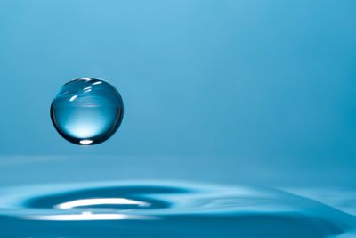

What is Wayback® Water ?
Our biological functions, including circulation, digestion, absorption, and cleansing, depend on water. The human body is anywhere from 55% to 78% water, depending on body size and age. A regular supply of clean water is essential for good health and to prevent degeneration of cells. Since water is vital to our health, the type and quality of water we take into our bodies is important.

For optimal health the water in our body’s cells should be constantly replaced. The old water moves out, carrying all the waste that has been created inside the cell, and fresh water transports nutrients into the cell.

Unfortunately, the water that is being consumed in the world today is made up of 95% to 97% water particles that are too big to enter through the cell wall. As a result many of our body’s cells just sit full of “sewage” water. Waste is not carried out and nutrients are not getting in with the necessary degree of efficiency. This greatly contributes to degeneration of cells and opens up the body for disease.

So why is the water that we are drinking made up of oversized particles? And what makes WayBack Water different from normal bottled water or water from the tap? When water goes through pipes, the structure of the particles is changed. The water particle increases in size. WayBack water has gone through a process which uses cutting edge quantum physics-based technology. The result is water particles which are .4 nanometer in size, making this water small enough to easily enter the body’s cells.

If you drink WayBack Water daily, all the water in your body’s cells will be regularly replaced. Toxins inside the cells will now be removed by the body, and nutrients will constantly be delivered to your cells. How long will it take for you to become completely hydrated and for all the “sewage” water in your body’s cells to be replaced? This will vary – we are all so biochemically different and are dehydrated to different degrees.

One thing is for certain – by drinking this water daily, you gradually will become more and more hydrated, slow down the degeneration going on in your body, and give your body one of the most important tools it needs to stay in good health.

